ARTIFICIAL INTELLIGENCE – DEFINITION, CONCEPTS, APPLICATIONS AND FUNDAMENTALS
AI-Assisted Academic Document Creation Using Gemini

Student Name: K. SUMANASRI
Register Number: 261FB04017
Programme: M.Tech
Branch: CSE
Subject: AI
Course Code:
Academic Year: 2026 – 2027
College/University: Vignan's Foundation for Science, Technology & Research (Deemed to be University)
Faculty Name: Mr.Kahadersh
Date: 6-10-2026

TABLE OF CONTENTS
1. Introduction
2. Definition of Artificial Intelligence
3. Evolution of Artificial Intelligence
4. Characteristics of Artificial Intelligence
5. Major Components and Technologies of AI
6. Relationship Between AI, Machine Learning and Deep Learning
7. Applications of Artificial Intelligence
8. Real-World Examples
9. Advantages of Artificial Intelligence
10. Limitations and Challenges
11. AI Decision-Making Cycle
12. Future Scope of Artificial Intelligence
13. Ethical and Responsible AI
14. Conclusion
15. References

1. INTRODUCTION
The rapid advancement of computational power and data accessibility in the 21st century has catalyzed a technological revolution, at the heart of which lies Artificial Intelligence (AI). Artificial Intelligence represents a paradigm shift in computer science, moving away from rigid, rule-based programming toward dynamic systems capable of mimicking human cognitive functions. In traditional computing, a programmer explicitly writes every instruction the computer must follow to execute a task. In contrast, AI systems are designed to process vast amounts of data, identify underlying patterns, and autonomously learn from experience without requiring step-by-step human intervention.
The importance of AI in modern society cannot be overstated. It serves as the foundational technology driving everything from the personalized recommendations on our digital devices to the autonomous navigation systems in modern vehicles. It accelerates scientific discovery by analyzing complex genetic sequences, secures global financial networks by detecting microscopic anomalies in transaction data, and optimizes supply chains on a global scale. As data generation grows exponentially, AI provides the only scalable mechanism to extract meaningful, actionable insights from this digital noise.
For students and professionals, particularly at the postgraduate level (M.Tech), understanding Artificial Intelligence is no longer optional; it is an academic and professional imperative. Regardless of the specific engineering discipline—whether mechanical, civil, electrical, or software engineering—AI algorithms are increasingly being integrated to optimize designs, predict system failures, and automate complex workflows. Developing a foundational understanding of how these systems learn, reason, and make decisions equips future engineers with the analytical tools necessary to design intelligent, adaptive solutions for the world's most pressing challenges.

2. DEFINITION OF ARTIFICIAL INTELLIGENCE
Defining Artificial Intelligence requires examining the concept from multiple perspectives, ranging from highly technical academic models to practical, everyday understandings.
A. Concise Definition
Artificial Intelligence is the simulation of human intelligence processes by machines, especially computer systems, enabling them to learn, reason, and act autonomously.
B. Detailed Academic Definition
Key Definition: In the academic discipline of computer science, Artificial Intelligence is defined as the design and development of intelligent computational agents. These are autonomous systems that perceive their operating environment through inputs/sensors, process this information using statistical or logical algorithms, and take actions that maximize their probability of achieving specific, complex objectives efficiently.
C. Simple Student-Friendly Definition
Simply put, AI is a branch of computer science that makes machines smart. Instead of just doing exactly what they are told step-by-step, AI programs can learn from examples, recognize patterns, and figure out how to solve problems on their own.
D. Explanation of the Definition
To fully grasp this definition, it is crucial to break down the underlying concepts of human cognition that AI attempts to replicate. Intelligence in machines is not consciousness; rather, it is the mathematical ability to process information effectively. Learning refers to the machine's ability to improve its performance on a specific task over time by absorbing training data (such as machine learning). Reasoning implies applying logical rules to draw conclusions from incomplete data. Problem Solving involves navigating a vast set of possibilities to find an optimal solution path, while Perception is the interpretation of visual, auditory, or sensory data (like a self-driving car 'seeing' a pedestrian). Finally, Decision Making and Automation refer to the system executing an optimized choice repeatedly without human fatigue.

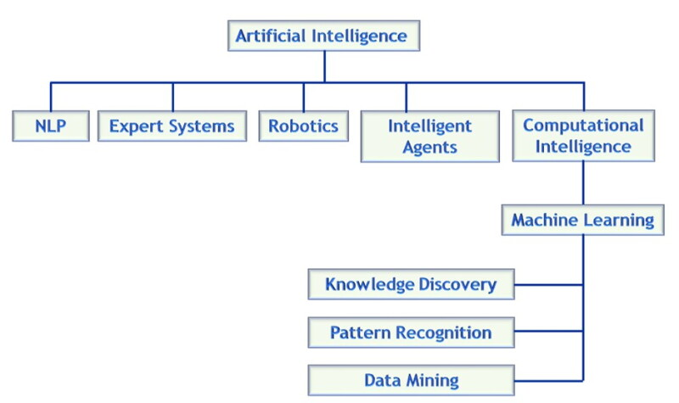
Figure 1: Basic Concept of Artificial Intelligence

Explanation: Raw data, logical rules, and sensory inputs feed into the central processing domains of learning, reasoning, and perception. These cognitive engines synthesize the information to form an Intelligent System, which ultimately executes a calculated decision or physical action.

3. EVOLUTION OF ARTIFICIAL INTELLIGENCE
The journey of Artificial Intelligence spans over seven decades, evolving from theoretical mathematics to the pervasive technology we use today. The field began in the mid-20th century, driven by the fundamental question of whether machines could think.

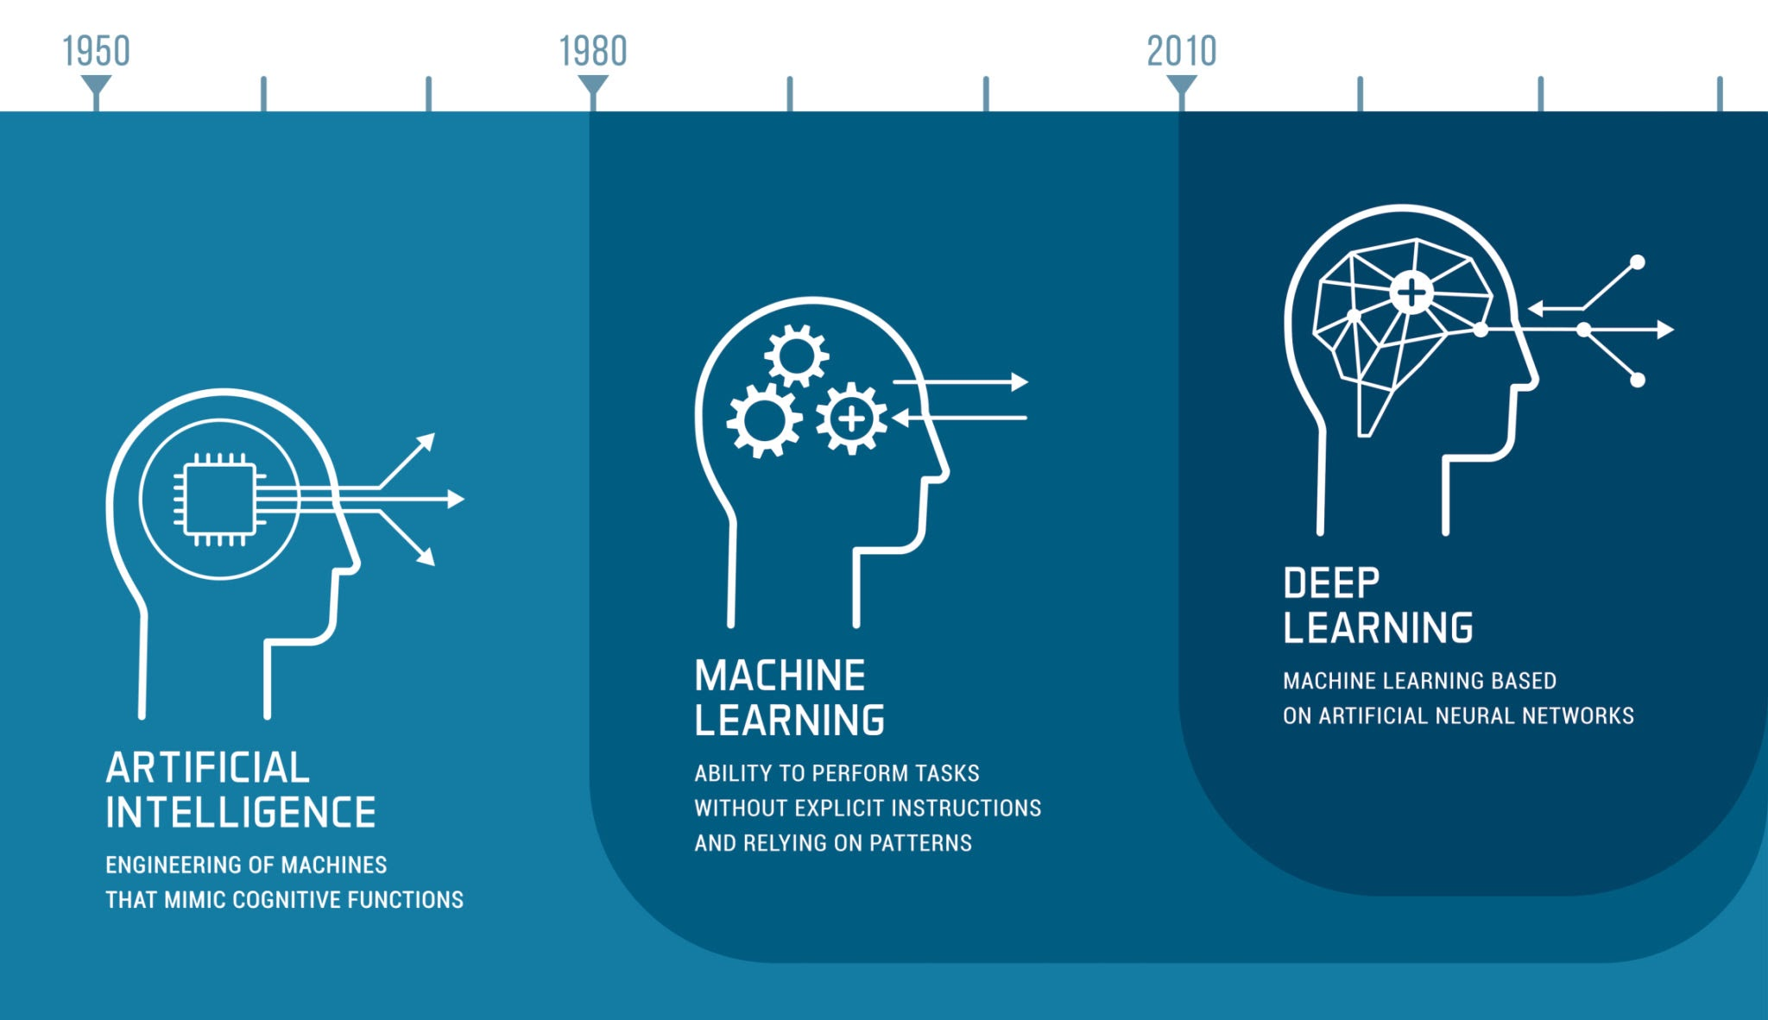
Figure 2: Evolution of Artificial Intelligence

Key Milestones:
- 1950 - Alan Turing & The Turing Test: Proposed a standard to measure machine intelligence.
- 1956 - The Dartmouth Conference: The term 'Artificial Intelligence' is officially coined.
- 1970s - Rule-Based Systems: Early computers programmed with complex 'if-then' logic.
- 1980s - Expert Systems: AI used in enterprise environments to mimic human experts.
- 1990s - Machine Learning Emergence: Shift from explicit programming to learning from data.
- 2010s - Deep Learning Revolution: Neural networks achieve human-level image and speech recognition.
- 2020s+ - Generative AI: Systems capable of creating original text, code, and imagery (e.g., LLMs).

4. CHARACTERISTICS OF ARTIFICIAL INTELLIGENCE
An advanced AI system is distinguished from standard software by several core characteristics that mimic human intellect.
Table 1: Key Characteristics of Artificial Intelligence

Characteristic | Meaning | Simple Example
1. Learning | Acquiring new knowledge from data without being explicitly programmed. | A spam filter learning to catch new types of scam emails.
2. Reasoning | Applying logic to draw conclusions from available data. | A medical AI deducing a diagnosis based on patient symptoms.
3. Problem Solving | Finding the most efficient path to reach a specific goal. | A chess engine calculating millions of moves to find the best play.
4. Knowledge Representation | Storing information in a structured way that the machine can utilize. | A database mapping out symptoms, diseases, and treatments logically.
5. Perception | Interpreting sensory input (images, sound) from the real world. | Facial recognition unlocking a smartphone.
6. Natural Language Processing | Understanding, interpreting, and generating human language. | Voice assistants understanding spoken commands.
7. Decision Making | Evaluating variables to choose the optimal action autonomously. | An autonomous vehicle deciding to brake for an obstacle.
8. Adaptability | Adjusting behavior when exposed to new environments or unseen data. | A robot vacuum updating its map when furniture is moved.

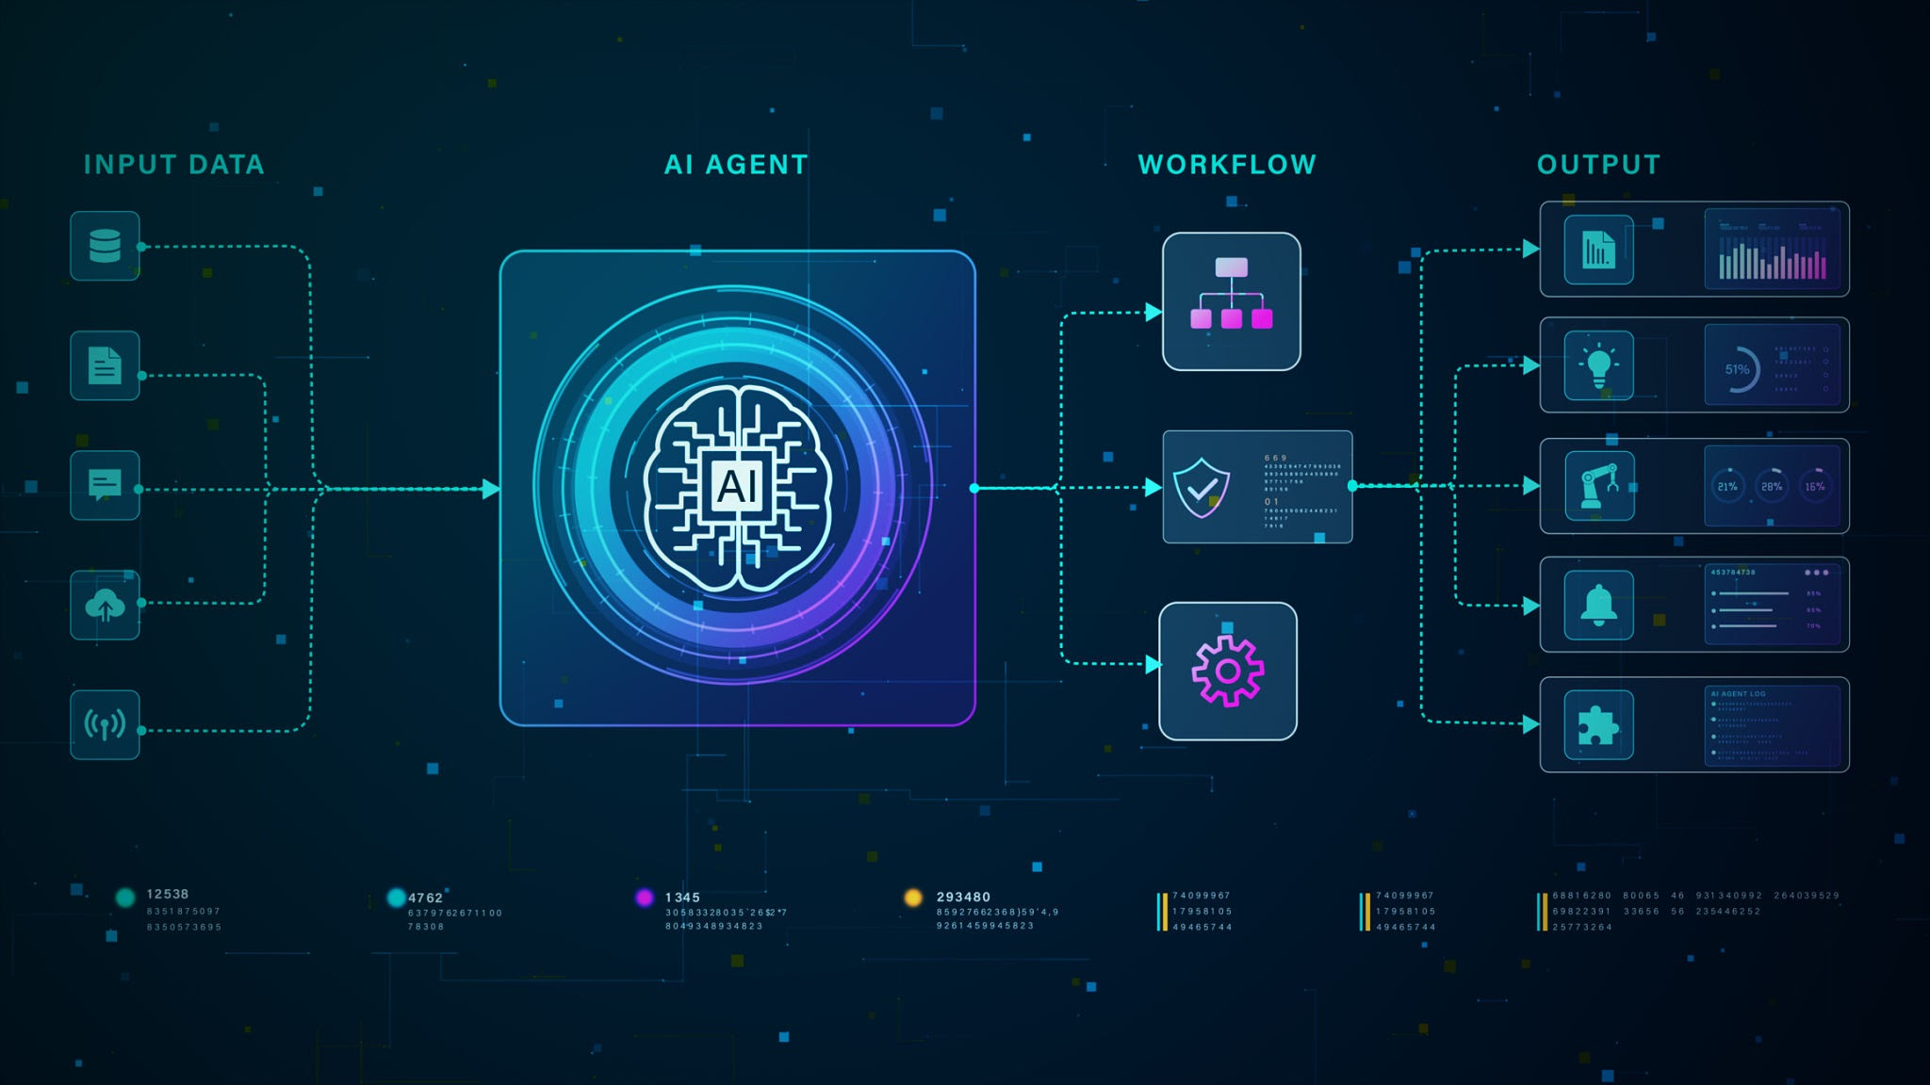
Figure 3: Major Characteristics of AI

5. MAJOR COMPONENTS AND TECHNOLOGIES OF AI
Artificial Intelligence is not a single technology but a broad umbrella encompassing several distinct sub-fields.
- Machine Learning (ML): The science of training algorithms using historical data so they can make predictions on new data.
- Deep Learning (DL): A subset of ML utilizing artificial neural networks with multiple layers (hence 'deep') to process highly unstructured data like images and audio.
- Natural Language Processing (NLP): Technologies that bridge the gap between human communication and computer understanding, enabling text analysis, translation, and conversational agents.
- Computer Vision (CV): Algorithms designed to process, analyze, and extract meaning from digital images and videos.
- Robotics: The integration of AI software with physical mechanical systems to perform automated, physical tasks in the real world.
- Expert Systems: Software designed to emulate the decision-making ability of a human expert in a highly specific domain.

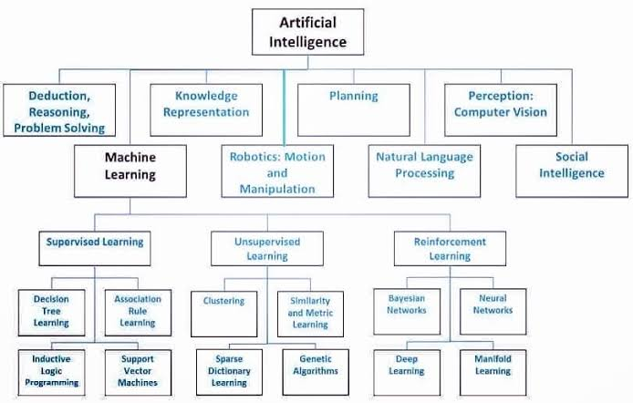
Figure 4: Major Technologies of Artificial Intelligence

6. RELATIONSHIP BETWEEN AI, MACHINE LEARNING AND DEEP LEARNING
A common point of confusion is the distinction between AI, ML, and DL. They are best understood as concentric circles.

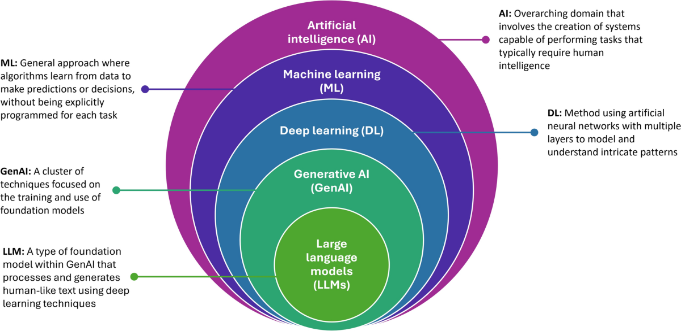
Figure 5: Relationship Between AI, ML and DL

Table 2: Comparison of AI vs ML vs DL
Feature | Artificial Intelligence (AI) | Machine Learning (ML) | Deep Learning (DL)
Definition | Umbrella term for machine intelligence. | Methods allowing machines to learn from data. | Neural networks with multiple hidden layers.
Data Requirement | Can operate on rules or data. | Requires structured data to train models. | Requires massive amounts of unstructured data.
Learning Approach | Logic, rules, or statistical learning. | Statistical feature extraction (often manual). | Automatic feature extraction through neural layers.
Example | A basic automated chess game. | Predicting house prices based on size/location. | Real-time facial recognition in crowds.
Applications | Chatbots, logic solvers, robotics. | Risk assessment, email filtering. | Autonomous driving, medical image scanning.

7. AI WORKING PROCESS
Understanding how an AI system processes information from start to finish is critical for engineers. An AI system operates in a continuous loop of data ingestion, processing, and output.

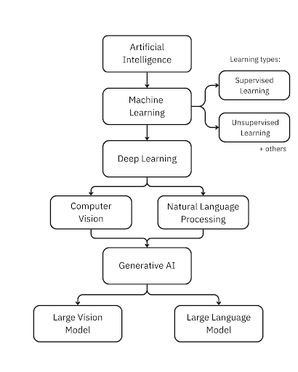
Figure 6: General Working Process of an AI System

- 1. Data/Input: The system ingests raw data (text, images, sensor metrics).
- 2. Data Processing: Data is cleaned, normalized, and formatted for the algorithm.
- 3. Feature/Information Extraction: Key attributes of the data are mathematically identified.
- 4. Learning/Reasoning: The algorithm applies statistical weights to understand patterns.
- 5. Model/System: A trained model is generated based on the learning phase.
- 6. Prediction/Decision: The model encounters new data and predicts an outcome.
- 7. Action: The system executes a task based on the prediction.
- 8. Feedback: The accuracy of the action is measured, feeding back into the system.

8. APPLICATIONS OF ARTIFICIAL INTELLIGENCE
AI has transcended research laboratories to become an integral part of industrial and commercial infrastructures.

Table 3: Applications of Artificial Intelligence
Domain | AI Application | Example | Benefit
1. Healthcare | Medical Diagnostics | AI analyzing MRI scans to detect early tumors. | Higher accuracy and earlier disease detection.
2. Education | Adaptive Learning | Intelligent tutoring systems tailoring math problems. | Personalized education based on student pace.
3. Banking and Finance | Fraud Detection | Flagging abnormal credit card transactions globally. | Preventing billions in financial theft instantly.
4. Transportation | Autonomous Systems | Self-driving cars navigating complex city streets. | Reducing human error and optimizing traffic.
5. Manufacturing | Predictive Maintenance | Sensors predicting when a factory machine will fail. | Eliminating costly unexpected downtime.
6. Agriculture | Precision Farming | Drones monitoring crop health and soil moisture. | Maximizing crop yield while saving water.
7. Cybersecurity | Threat Intelligence | AI detecting network intrusions in real-time. | Outpacing human security analysts in speed.
8. E-Commerce | Recommendation Engines | Amazon suggesting products based on browsing. | Increasing user engagement and sales.
9. Entertainment | Content Generation | AI generating special effects or video game logic. | Reducing production costs and time.
10. Smart Cities | Resource Optimization | AI managing power grid distribution efficiently. | Reducing energy waste and carbon footprints.

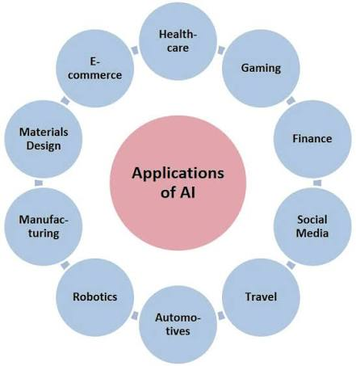
Figure 7: Applications of Artificial Intelligence

9. REAL-WORLD EXAMPLES
To bridge the gap between academic theory and daily reality, consider these 8 highly recognizable examples of AI in action:
- Voice Assistants (Siri/Alexa): Utilizes Natural Language Processing to convert spoken audio into text, comprehend the intent, and query databases to return spoken answers. Useful for hands-free productivity.
- Recommendation Systems (Netflix/YouTube): Analyzes millions of user viewing histories using collaborative filtering to accurately predict what movie you will want to watch next. Useful for content discovery.
- Face Recognition (Smartphone Unlock): Uses Computer Vision and Deep Learning to map facial geometry in 3D, comparing it against a stored mathematical model to securely unlock devices. Useful for biometric security.
- Chatbots (Customer Service): Generative AI and NLP algorithms that understand customer text queries and provide human-like, contextually accurate support without human intervention. Useful for 24/7 business scaling.
- Medical Image Analysis: Deep convolutional neural networks trained on millions of X-rays to highlight microscopic anomalies (like fractures or lesions) faster than a radiologist. Useful for life-saving diagnostics.
- Autonomous Systems (Drones): AI combining GPS, computer vision, and dynamic physics calculations to navigate complex terrains autonomously. Useful for delivery or military reconnaissance.
- Fraud Detection (Credit Cards): Machine learning classifiers that constantly monitor purchasing locations, amounts, and frequencies to freeze stolen cards instantly. Useful for financial protection.
- Generative AI (ChatGPT/Midjourney): Large Language Models (LLMs) and diffusion models that predict the next logical word or pixel to create entirely original essays, code, and artwork from simple prompts. Useful for rapid content creation.

10. ADVANTAGES OF AI

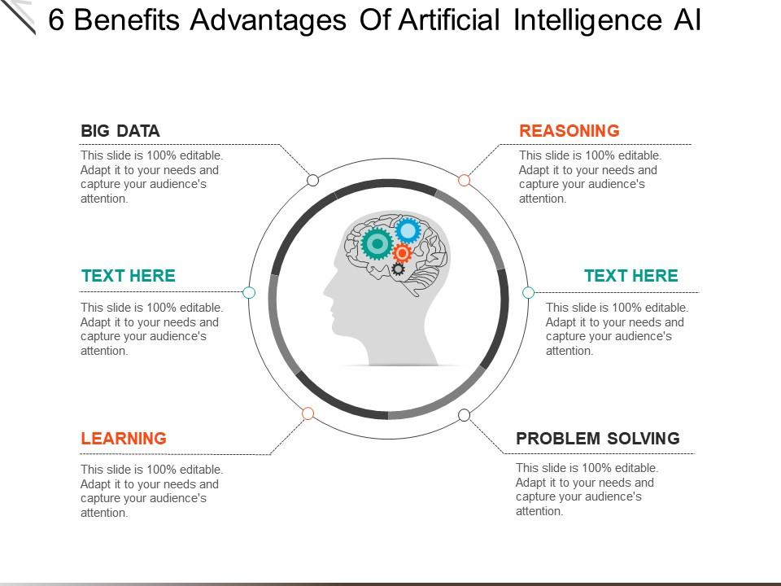
Figure 8: Advantages of Artificial Intelligence

- 24/7 Availability: AI systems do not require rest, operating continuously without fatigue.
- High Accuracy & Precision: Eliminates human errors caused by lack of concentration or exhaustion.
- Unmatched Speed: Analyzes terabytes of data in milliseconds, far exceeding human cognitive limits.
- Automation of Repetitive Tasks: Frees human workers from mundane tasks to focus on creative strategy.
- Objective Decision Making: Makes decisions based purely on data mathematics, devoid of emotional bias.
- Handling Big Data: The only technology capable of structuring and finding meaning in massive datasets.
- Hazardous Environments: AI robots can operate in space, deep sea, or radioactive zones safely.
- Personalization: Delivers customized experiences to millions of users simultaneously.

11. LIMITATIONS AND CHALLENGES
Despite its revolutionary potential, AI development is constrained by several critical challenges.
Table 4: AI Challenges and Solutions
Challenge | Explanation | Possible Mitigation
Data Dependency | AI requires massive amounts of clean, labeled data to function. | Utilizing synthetic data generation to train models.
Bias | AI inherits human prejudices present in the training data. | Implementing strict fairness auditing in datasets.
Privacy Concerns | AI requires personal data, which can infringe on user privacy. | Using federated learning and data anonymization.
Security Risks | AI can be manipulated via adversarial attacks or used for hacking. | Strengthening cybersecurity protocols and AI defenses.
High Computational Requirements | Training advanced AI requires massive energy and expensive GPUs. | Optimizing algorithms and designing efficient AI chips.
Lack of Explainability | Deep learning models often act as a 'black box' (unclear logic). | Developing eXplainable AI (XAI) frameworks.
Job Displacement Concerns | Automation threatens certain manual and administrative roles. | Workforce reskilling and focusing on human-AI collaboration.
Ethical Issues | AI making moral decisions (e.g., self-driving crash logic). | Establishing global AI governance and ethical guidelines.

12. AI DECISION-MAKING CYCLE
The AI decision-making process is not linear; it is highly iterative.

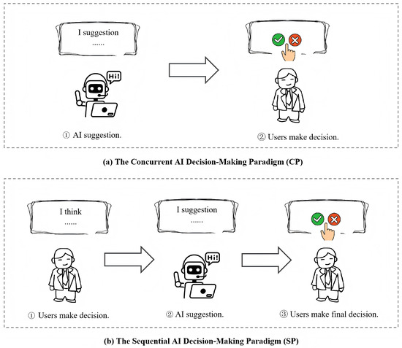
Figure 9: AI Decision-Making Cycle

1. Input/Data -> 2. Analysis -> 3. Learning/Reasoning -> 4. Decision -> 5. Action -> 6. Feedback (Loops back to Input)

13. FUTURE SCOPE OF ARTIFICIAL INTELLIGENCE
The future trajectory of AI promises to blur the lines between human and machine capabilities. Key areas of future scope include:
- Generative AI: Moving beyond text and images to generate complex software architecture and fully synthesized video dynamically.
- AI Agents: Moving beyond prompt-response systems to AI agents capable of planning and executing multi-step goals over days or weeks autonomously.
- Healthcare: AI shifting from diagnostics to personalized medicine, predicting illnesses years before they manifest based on genomic data.
- Robotics: AI models integrated directly into humanoid robotics, capable of learning physical tasks by observing humans.
- Autonomous Systems: City-wide integration of autonomous vehicles communicating with smart infrastructure to eliminate traffic lights and accidents.
- Education: Hyper-personalized AI tutors that adapt in real-time to a student's cognitive state and emotional frustration levels.
- Scientific Research: AI systems autonomously formulating scientific hypotheses, running virtual experiments, and discovering new materials for clean energy.
- Smart Infrastructure: Cities managed entirely by AI, optimizing water distribution, grid power, and waste management based on real-time population movements.

14. ETHICAL AND RESPONSIBLE AI
As AI systems gain autonomy, integrating ethical frameworks is crucial for societal safety.

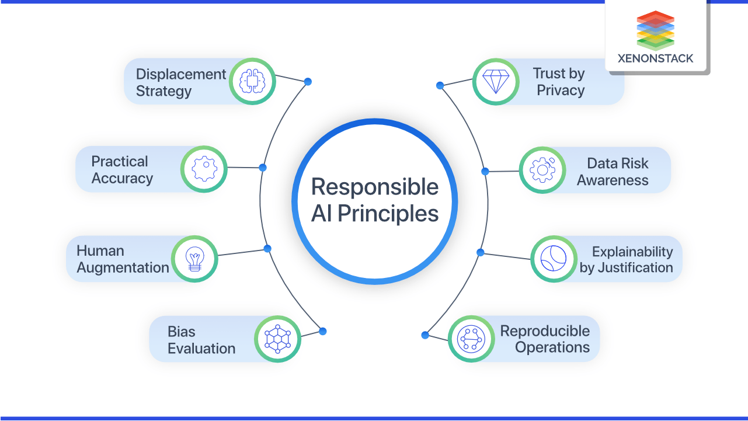
Figure 10: Principles of Responsible AI

- Fairness: Systems must treat all demographic groups equitably without discrimination.
- Transparency: AI decision processes should be understandable and traceable by humans.
- Accountability: Clear legal and moral responsibility for AI outcomes must be established.
- Privacy: AI must respect user data confidentiality and comply with global data laws.
- Safety: Algorithms must be robust against manipulation and fail safely in edge cases.
- Human Oversight: Critical decisions (e.g., medical, judicial) must retain a 'human-in-the-loop.'

15. CONCLUSION
Artificial Intelligence represents a monumental leap in the evolution of computational science. As defined in this document, AI is the simulation of human cognitive abilities by machine systems, empowering them to learn, reason, perceive, and make autonomous decisions. Through the integration of core technologies such as Machine Learning, Deep Learning, Natural Language Processing, and Computer Vision, AI has evolved from early rule-based logic to highly sophisticated neural networks capable of unprecedented computational feats.
The applications of AI are profoundly reshaping global infrastructure. From revolutionizing medical diagnostics in healthcare and optimizing high-frequency trading in finance, to enabling autonomous transportation and predictive manufacturing, the benefits are vast. AI offers the unmatched advantages of 24/7 operational capability, extreme precision, and the ability to extract actionable insights from big data.
However, as explored in the limitations and ethical considerations, this technology is not without significant challenges. Issues regarding data bias, algorithmic transparency, high computational costs, and workforce displacement require careful, interdisciplinary management. Ensuring that AI adheres to strict principles of fairness, accountability, and safety is essential as we move toward an era of autonomous AI agents and potential Artificial General Intelligence (AGI). Ultimately, the future of AI is not about machines replacing human intellect, but rather augmenting it—providing engineers and scientists with the ultimate analytical tool to solve the complex, dynamic problems of the modern world.

16. REFERENCES
- Russell, S. J., & Norvig, P. (2020). Artificial Intelligence: A Modern Approach (4th ed.). Pearson.
- Goodfellow, I., Bengio, Y., & Courville, A. (2016). Deep Learning. MIT Press.
- Mitchell, T. M. (1997). Machine Learning. McGraw-Hill Education.
- Nilsson, N. J. (2009). The Quest for Artificial Intelligence: A History of Ideas and Achievements. Cambridge University Press.
- Bishop, C. M. (2006). Pattern Recognition and Machine Learning. Springer.
- Turing, A. M. (1950). Computing Machinery and Intelligence. Mind, 59(236), 433-460.
- Jobin, A., Ienca, M., & Vayena, E. (2019). The global landscape of AI ethics guidelines. Nature Machine Intelligence, 1(9), 389-399.

